Delivery Analytics API - Internship Task Report

1. Title Page
Title: Delivery Analytics API
Intern Name: Nandhitha Maraka
Date of Task Given: 24-06-26
Supervisor: Dishika Gupta
Project Handler: Vasudha Tayade
Team Members: NA
My Role
Developed a FastAPI-based Delivery Analytics API that receives email webhook events, stores them in a SQLite database, validates incoming requests, prevents duplicate events, and provides analytics on email delivery performance.

2. Executive Summary
The Delivery Analytics API project was developed to monitor the effectiveness of email notifications by tracking delivery-related events received through provider webhooks. The system records events such as sent, delivered, opened, clicked, and bounced emails in a SQLite database and provides summarized analytics through REST APIs.
The project successfully implemented webhook handling, database integration, duplicate event prevention, event validation, and analytics generation. The API returns both event counts and delivery performance metrics, enabling users to analyze notification effectiveness efficiently.

3. Task Overview

Task Description
My responsibility was to develop the backend service responsible for receiving email delivery webhook events, storing them securely, validating incoming requests, and generating delivery analytics.

Objective
The objective of this module was to measure notification effectiveness and identify email delivery issues by tracking email lifecycle events.

Scope
The work included:
- FastAPI backend development
- REST API implementation
- SQLite database integration
- SQLAlchemy ORM implementation
- Pydantic request validation
- Analytics calculation
- API testing using Swagger UI
- Edge case handling

4. Technologies Used
Programming Language
- Python 3.12
Framework
- FastAPI
Database
- SQLite
ORM
- SQLAlchemy
Validation
- Pydantic
Server
- Uvicorn
Tools
- VS Code
- Git
- GitHub
- Swagger UI
- Postman (optional)
Libraries
- fastapi
- sqlalchemy
- uvicorn
- pydantic

5. Implementation Details

Step 1
Created the project structure consisting of:
- app.py
- database.py
- models.py
- schemas.py
- crud.py
- requirements.txt
- README.md

Step 2
Configured SQLite database using SQLAlchemy.

Step 3
Designed the EmailEvent database model.
Fields:
- event_id
- email
- event
- timestamp

Step 4
Implemented POST /webhook API.
Features:
- Receives webhook events
- Validates event type
- Prevents duplicate events
- Stores data in SQLite
Example Request
{
"event_id":"1001",
"email":"abc@gmail.com",
"event":"delivered",
"timestamp":"2026-06-26 10:00:00"
}

Example Response
{
"message":"Webhook stored successfully"
}

Step 5
Implemented GET /analytics API.
The API calculates:
- Email Sent
- Delivered
- Delivery Rate
- Opened
- Open Rate
- Clicked
- Click Rate
- Bounced
- Bounce Rate
Sample Response
{
"email_sent":200,
"delivered":195,
"delivery_rate":"97.5%",
"opened":140,
"open_rate":"71.79%",
"clicked":80,
"click_rate":"57.14%",
"bounced":5,
"bounce_rate":"2.5%"
}

6. Testing & Validation
Testing Methods
- Swagger UI
- FastAPI Interactive Documentation
- Manual API Testing
Test Cases
✓ Valid webhook event
✓ Duplicate event
✓ Invalid event type
✓ Missing required fields
✓ Analytics generation
Challenges During Testing
- Uvicorn installation issue inside virtual environment
Solution
Installed dependencies within the virtual environment using:
python -m pip install fastapi uvicorn sqlalchemy pydantic

7. Results & Outcome
The Delivery Analytics API successfully:
- Stored webhook events
- Generated delivery analytics
- Calculated delivery rates
- Calculated open rates
- Calculated click rates
- Calculated bounce rates
- Prevented duplicate events
- Returned proper HTTP responses
The module successfully met the project objectives.

8. Challenges & Solutions

Challenge 1
Duplicate webhook events.
Solution
Implemented unique event_id validation before storing events.

Challenge 2
Invalid event types.
Solution
Validated incoming events against predefined supported event types.

Challenge 3
Division by zero during analytics.
Solution
Handled empty database scenarios by returning zero percentages.

Challenge 4
Virtual Environment Package Issue
Solution
Installed required packages within the active virtual environment.

9. Conclusion
The Delivery Analytics API was successfully developed and tested. The application provides a reliable mechanism for receiving email delivery webhook events, storing them securely, and generating analytics that help measure notification effectiveness.
Throughout this task, I gained practical experience in FastAPI development, REST API design, SQLAlchemy ORM, SQLite database management, API testing, GitHub version control, and debugging deployment issues.

10. References
FastAPI Documentation
https://fastapi.tiangolo.com/
SQLAlchemy Documentation
https://docs.sqlalchemy.org/
Pydantic Documentation
https://docs.pydantic.dev/
Uvicorn Documentation
https://www.uvicorn.org/
SQLite Documentation
https://www.sqlite.org/
GitHub Repository

https://github.com/nandithasri2006/Delivery_Analytics/tree/main

Project Folder Structure
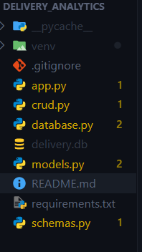
Swagger Home Page
(GET /)
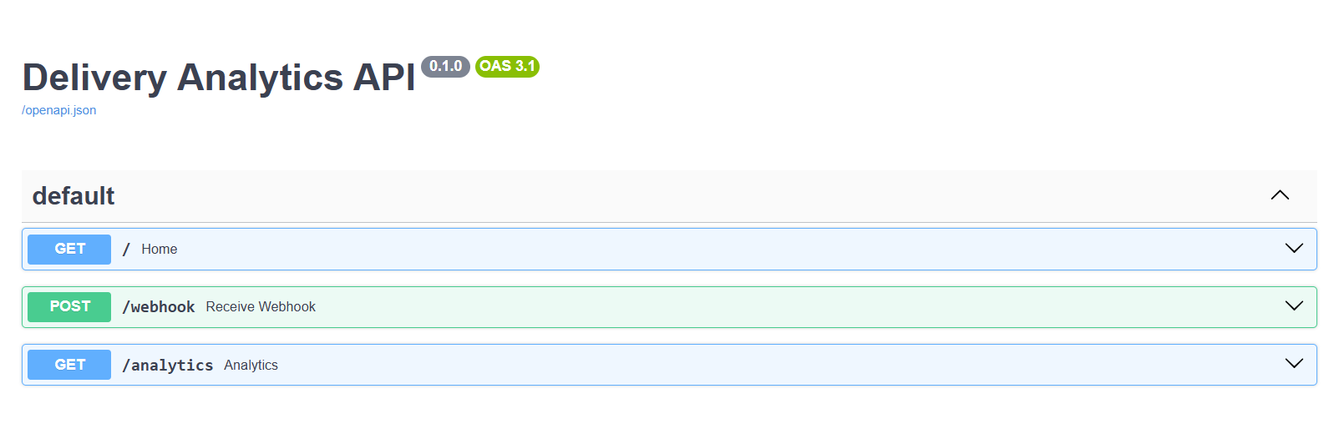

POST /webhook Request
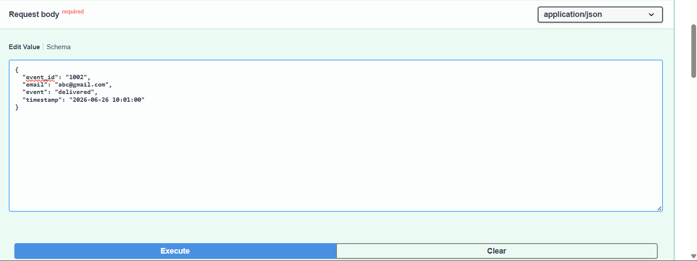

POST /webhook Success Response
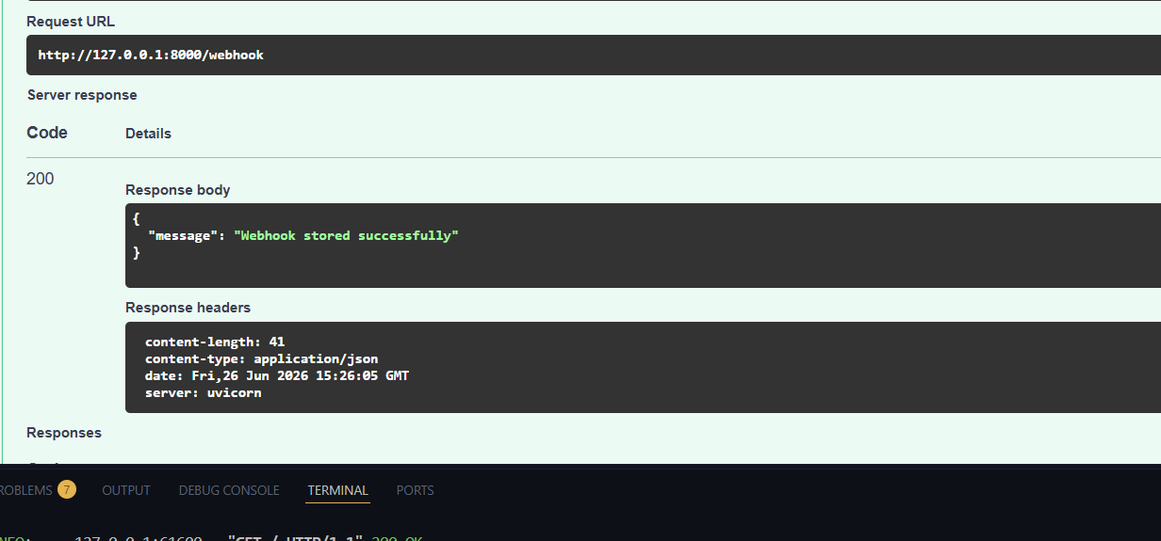

GET /analytics Response
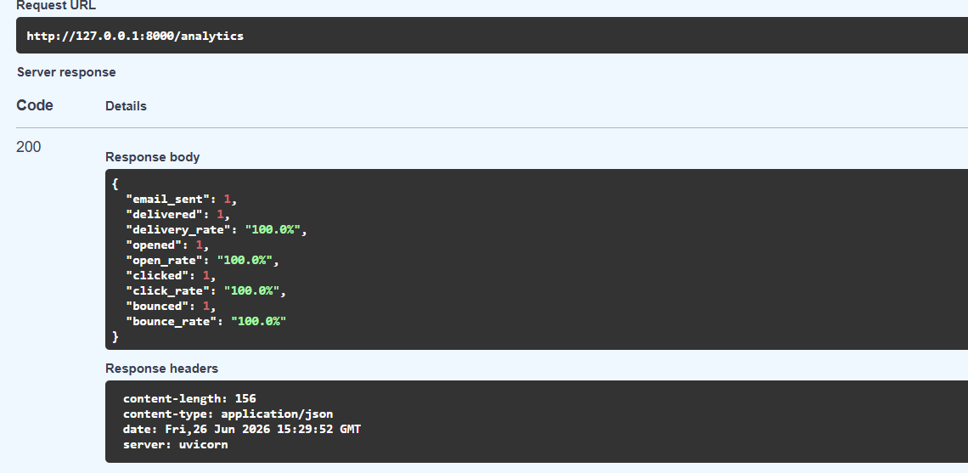

Duplicate Event Response
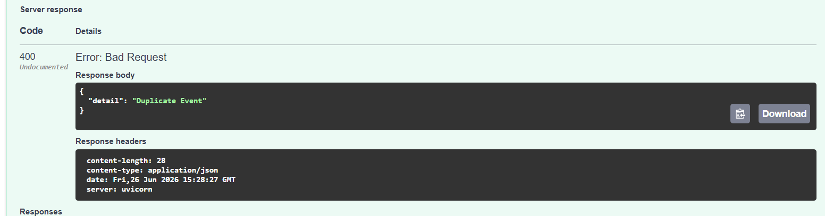

Invalid Event Response
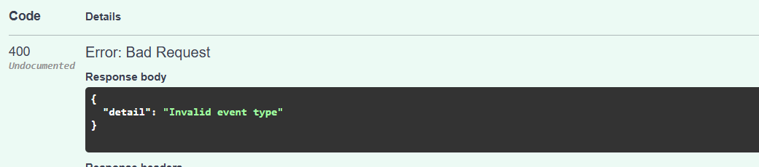

GitHub Repository
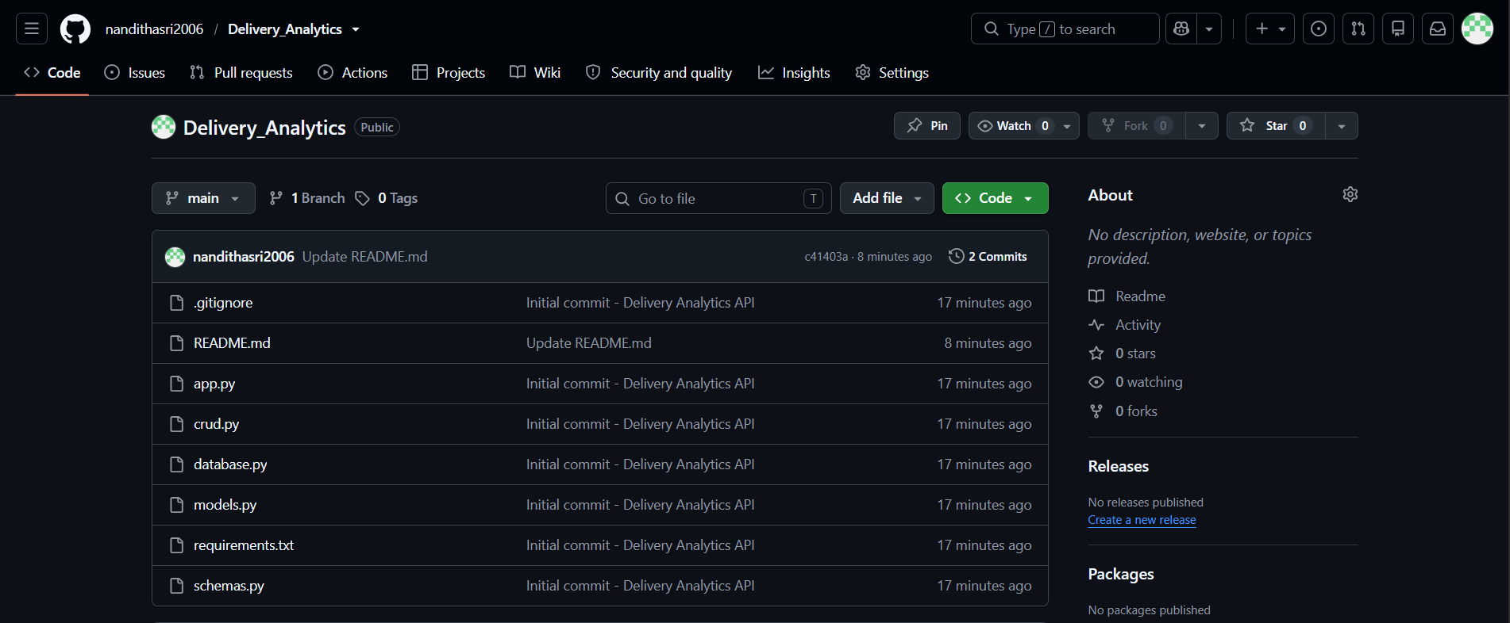

Submission Details
GitHub Repository:
https://github.com/nandithasri2006/Delivery_Analytics
Submission Date:
26-06-2026
Submitted To:
Vasudha Tayade

